Instructions on build and execute solution.

Solution can be executed following below 2 ways.

1. Open solution in Visual Studio Management studio and run the application by clicking on start button as shown below.

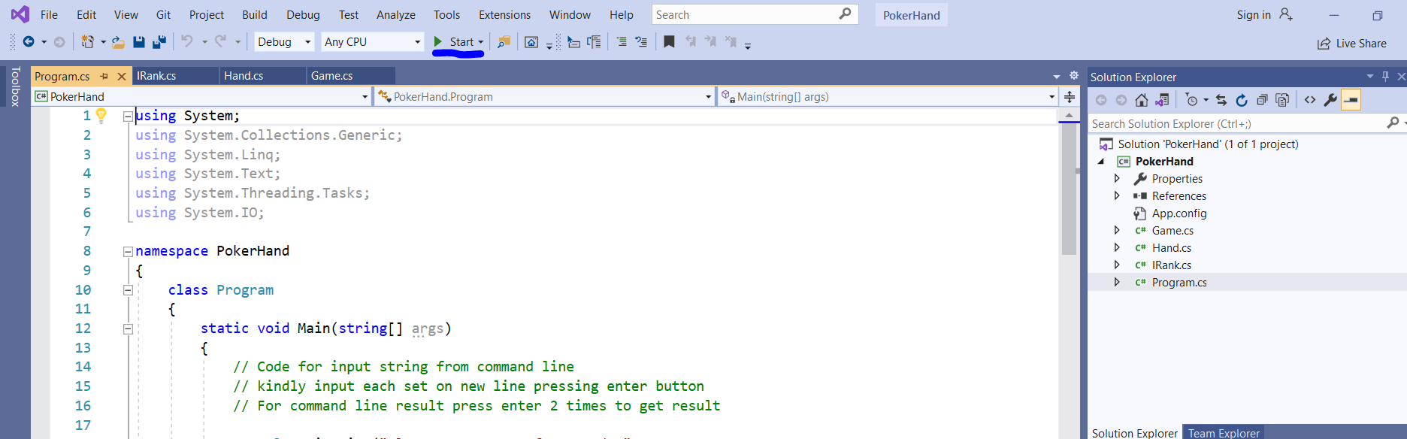

1. Open command prompt by typing cmd on windows start menu

Type cd <project file path> till Debug folder and execute PokerHand.exe file

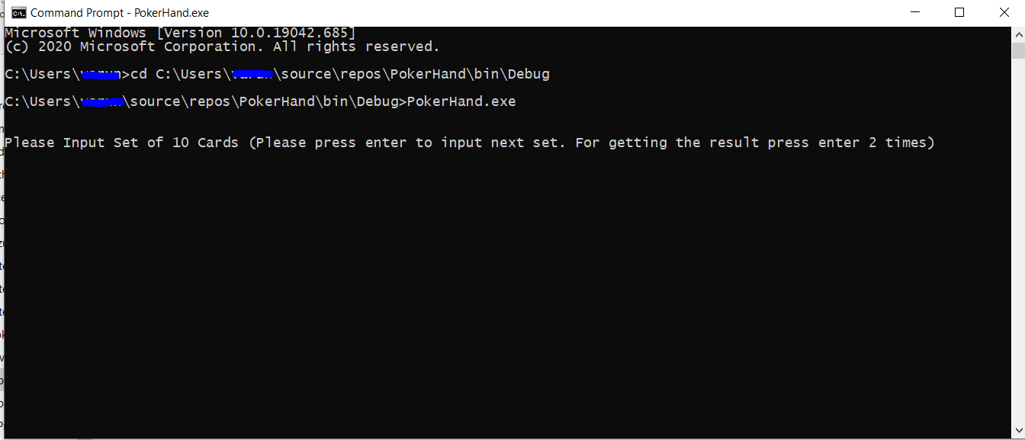

Follow the instructions on command prompt to get the result

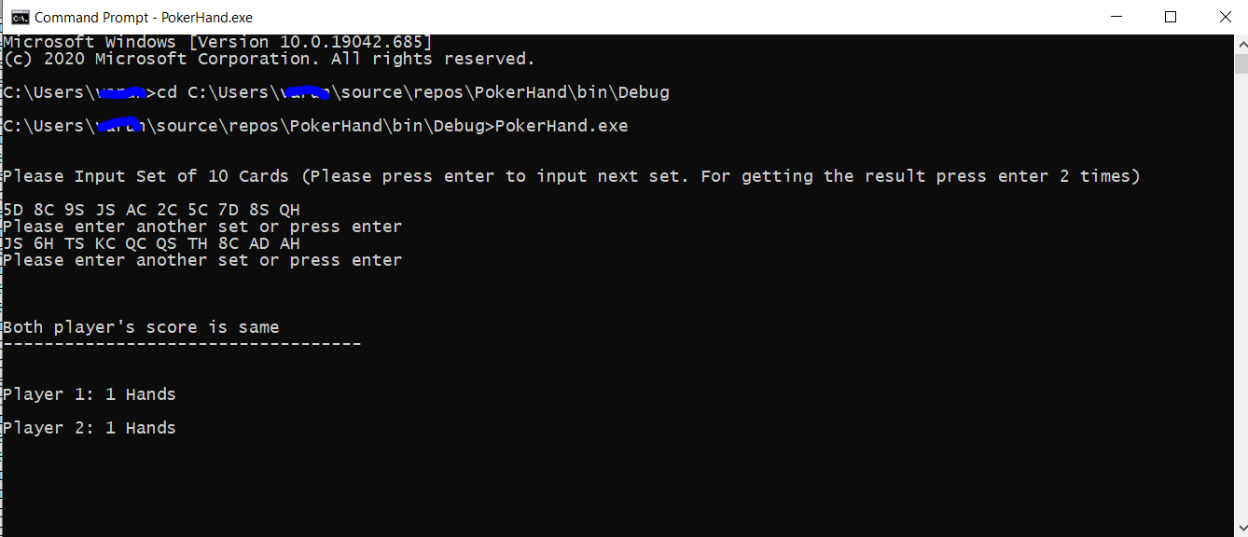

To read the text file for input cards set and get the results kindly uncomment below code in Program.cs file and build the solution.

